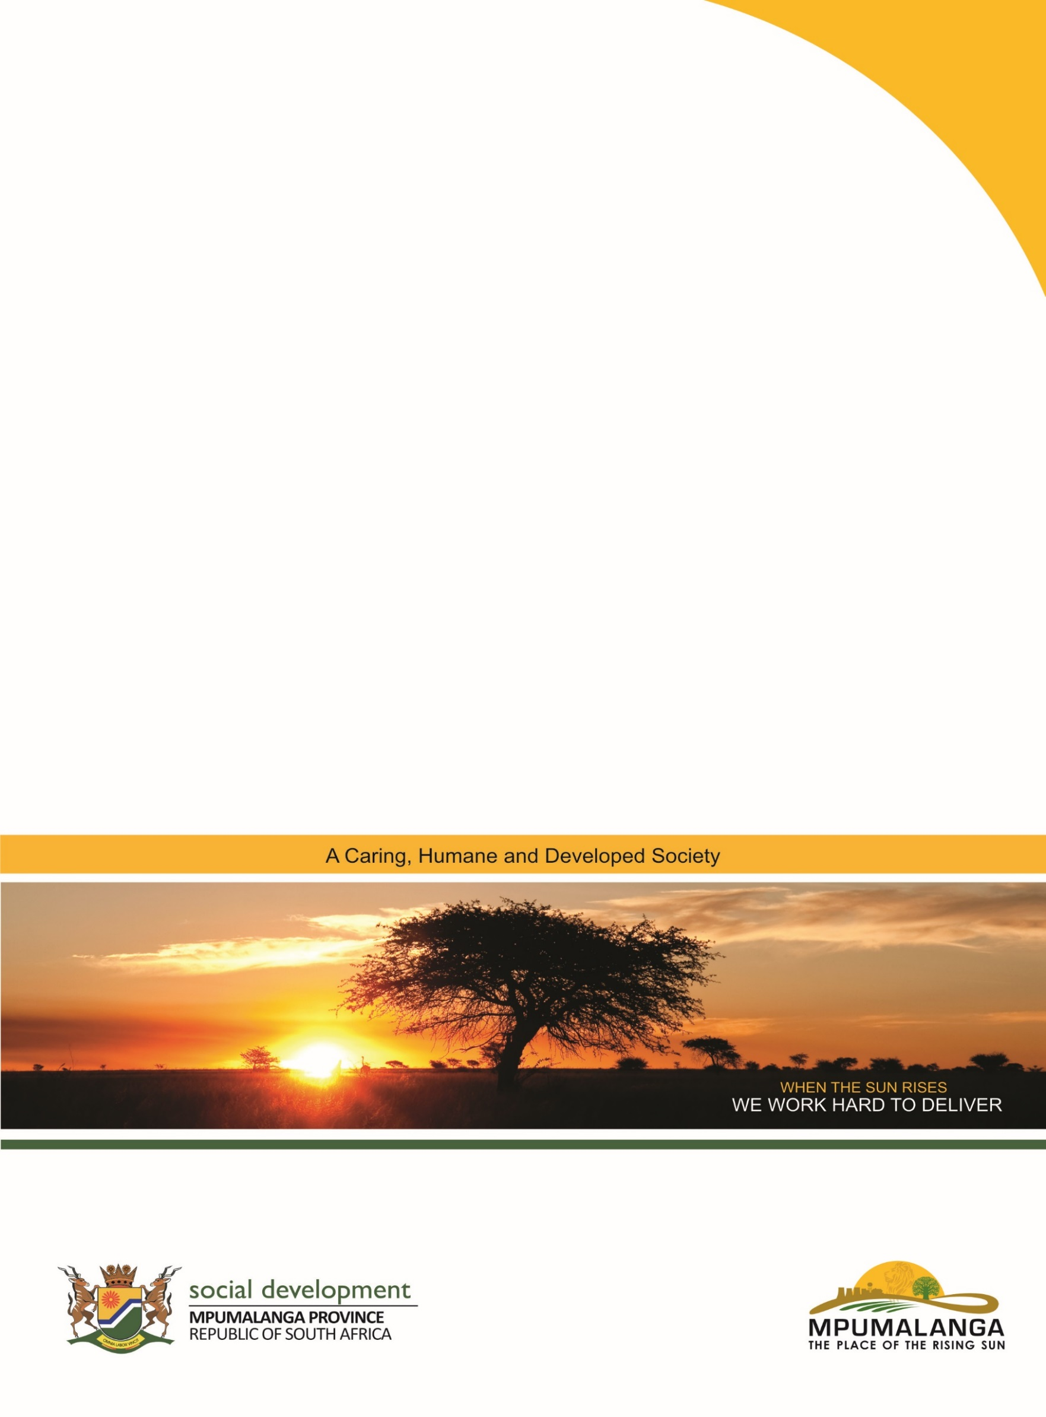
SERVICE SPECIFICATIONS
2024/25 to 2026/27
NPO SERVICE SPECIFICATIONS

2019/20
Contents
1. Introduction 3
2. General information regarding specifications 3
2.1 Conditions for funding 3
2.2 Business Plans / Proposals 4
2.3 Legislation and Work Methods 4
3. YOUTH AND WOMEN DEVELOPMENT 6
3.1 Youth Development 6
3.1.1 Provision of Youth Development Services and Programmes (Youth Development Centres) 6
3.2 Women Development 8
3.2.1 Provision of Women Empowerment Programmes and Service (Women Development Centres) 8
4 Enquiries 9

- Introduction

The aim of the Policy on Financial Awards to Service Providers is to guide the provincial response to the financing of service providers, facilitate transformation and redirect services to the poor and vulnerable sectors of the community.

The policy outlines that service specifications determine priorities for service delivery. Service specifications are informed by provincial demographics, community needs, research, community meetings such as Imbizo’s, presidential and/or ministerial pronouncements, Integrated Development Plans, provincial priorities, etc.

Service specifications determine where, to whom and for what purpose funding will be allocated and must include amongst others the following:
- The type and intended focus of the service
- The specific area/s where the service is currently rendered and for which the service is required
- The target group/s that should be reached
- Objectives and outputs for the specific service
- List of documents that need to be submitted with the service plan
- The closing date for the submission of service plans
- The official(s) who can be contacted for any further enquiries

Service specifications are based on the following categories of services:
- Youth Development Services
- Women Empowerment Services

These categories are not exclusive and may be amended or modified by the executing authority of the department in accordance with national and provincial priorities and needs.

- General information regarding specifications

  - Conditions for funding

Organisations wishing to apply must comply with the following conditions:

- Must be a legal persona and registered in terms of the Nonprofit Organisations Act No. 71 of 1997.
- The organisation must have an approved constitution that embraces developmental objectives.
- Promote equitable distribution of services taking into account historical imbalance, including race, gender, and the urban/rural divide. The services should be directed to where the needs and priorities have been identified.
- Promote inclusiveness and representation in the management and organisation of services, including the establishment of management committees that broadly reflect demographics of communities that they serve.
- Is able to account for the utilisation of financial awards made by the department in an acceptable manner and in terms of the prescripts of the Public Finance Management Act 1 of 1999 (PFMA).

  - Business Plans / Proposals

Organisations applying for funding should complete a Business Plan proposal, the format of which can be obtained from the nearest Department of Social Development office.

Business Plan proposals should be submitted, before or on the return date, to the nearest Department of Social Development office.

The following documents should accompany Business Plan proposals:

  - Constitution – stamped, signed and dated
  - Employment contracts of current staff
  - Floor Sketch of the building used for the service (approximate)
  - Lease agreement or Right/Permision to occupy in respect of building utilised for service delivery.
  - Procedure to elect Board members (if not included in the Constitution) / Minutes and attendance register of the AGM in which the Management Board was elected
  - NPO Registration Certificate (Certified copy of the original)
  - NPO Compliance Report obtainable from the NPO Help Desk in the nearest sub-district Office of DSD.
  - Audited financial statements for 2021/22 financial year
  - Bank statements (Last six months)
- CSD Registration
- Bank account confirmation letter
  - Assurance In Terms Of Section 38(1)(J) Of The Public Finance Management Act, 1999 (Act 1 Of 1999)
  - Declaration of Interest
  - Certified ID copies of Board members and signatories.
  - Proof of registration for UIF (Proof of Registration or recent proof of payment)
  - Proof of compliance with COIDA (Letter of Good Standing Issued)
  - Valid Tax Clearence (PIN) and/or Proof of tax compliance

  - Legislation and Work Methods

The following overarching legislation should be adhered to, i.e.

- Constitution of South Africa (108 of 1996)
- White Paper for Social Welfare (1997)
- Policy on Financial Awards to Service Providers
- Public Finance Management Act (1 of 1999)
- Promotion of Administrative Justice Act (3 of 2000)
- Promotion of Access to Information Act (2 of 2000)
- Notprofit Organisations Act (71 of 1997)
- Social Assistance Act (13 of 2004)
- National Development Plan 2030
- Advisory Boards on Social Development Act, 2001 (3 of 2001)
- Integrated Service Delivery Model
- Population Policy for South Africa, 1998
- Labour Relations Act, 1995 (75 of 1995)
- Basic Conditions of Employment Act, 1997 (75 of 1997)
- Occupational Health and Safety Act, 1993 (85 of 1993)
- Employment Equity Act, 1998 (55 of 1998)
- Unemployment Insurance Act
- COIDA
- Intergovernmental Relations Framework Act, 2005 (Act 13 of 2005)

The following work methods and programme specific legislation should be adhered to, i.e.

Service | Work Method | Legislation
Youth Development | - Group training  - Community services  - Individual services.  - Management and administration.  - Information programme.  - Use of personnel and volunteers. | - Policy and Guidelines on Youth Development Centres.  - National Strategic Plan for HIV and AIDS 2007-2011  - National Youth Development Agency Act (54 of 2008)  - National Youth Policy 2021 - 2030  - DSD Youth Policy 2021 – 2030  - Youth Employment Accord  - Youth Skills Accord  - National Youth Service Framework
Women Development | - Group training  - Community services  - Individual services  - Aftercare  - Management and administration.  - Information programme.  - Use of personnel and volunteers. | - Women Development Draft Framework (2016)  - National Strategic Plan for HIV and AIDS 2007-2011  - Domestic Violence Act (Act 116 of 1998)  - Sexual Offences Act (Act 23 0f 1957)  - Convention on the Elimination of All forms of Discrimination against Women (Beijing Platform of Action)  - DSD Women Empowerment Policy 2023  - South African National Policy Framework for Women Empowerment and Gender Equality  - The National Gender Policy Framework on Women’s Empowerment and Gender, 2000 (The National Gender Policy)  - Sanitary Dignity Implementation Framework, 2019  - Sexual offences: Criminal Law (Sexual Offences and Related Matters) Amendment Act and the Sexual Offences Act, 2007 (Act 32 of 2007)  - National Strategic Plan on Gender-Based Violence & Femicide (2020 – 2030)  - Preferential Procurement Policy Framework Act (Act no. 5 of 2000).  - The Promotion of Equality and Prevention of Unfair Discrimination Act (Act no. 4 of 2000)

- YOUTH AND WOMEN DEVELOPMENT

  - Youth Development

    - Provision of Youth Development Services and Programmes (Youth Development Centres)

CATEGORY OF SERVICE: | Provision of Youth Development Services and Programmes.
SERVICE DESCRIPTION: | To provide information to young people on education and training, employment, self- employment, active citizenry, health and wellbeing through walk-ins, one-on-one consultations, dissemination of information, workshops and trainings, mentoring and coaching.
AIM: | To increase access to services aimed at social and economic empowerment of youth.
DISTRICTS | Gert Sibande, Nkangala and Ehlanzeni.
TARGET GROUP | - Youth in school  - Out-of-school youth  - Unemployed youth  - Youth clubs

SERVICES REQUIRED

OBJECTIVES | OUTPUT | TYPE OF SERVICES
- To ensure access programmes and services aimed at social and economic empowerment of youth through provision of information, mentorship education and training. | - Well-informed and empowered youth.  - Sustainable livelihoods for youth. | Awareness Programme and Educational Programmes  - Life skills education for the youth.  - Career Guidance and Counselling for school going youth  - Entrepreneurship development for Job creation, skills training and income generation.  - Basic Computer Literacy.  - Commemoration of Youth Day calendar events.  - Access to information.  - Mentorship and Coaching
- To ensure effective and efficient management and administration of the Youth Development Centre | - Effective governance.  - Well-managed and sustainable services.  - Effective and participative management committees.  - Compliance with legislative requirements, norms and standards. | Governance support services  - Training, skills development and capacity building.  - Fundraising  - Personnel management.  - Financial management.  - Marketing of organisation and its services.  - Monitoring and evaluation
- To strengthen capacity of Youth Development Workers to render effective and efficient services in response to challenges faced by youth. | - Effective and Efficient implementation and facilitation of programmes and services  . | Capacity Building, Training and Facilitation Programmes:  - Development of training programmes  - Training, skills development and capacity building sessions.  - Mentoring and support of trained workers  - Monitoring and evaluation of training

SERVICES REQUIRED IN THE FOLLOWING AREAS:
Ehlanzeni | City of Mbombela, Nkomazi,Thaba Chweu, Bushbuckridge
Gert Sibande | Lekwa, Dr Pixley Ka Isaka Seme, Govan Mbeki, Dipaleseng, Msukaligwa, Mkhondo and Chief Albert Luthuli
Nkangala | Emalahleni, Steve Tshwete, Thembisile Hani, Dr JS Moroka, Emakhazeni, Victor Khanye

  - Women Development

    - Provision of Women Empowerment Programmes and Service (Women Development Centres)

CATEGORY OF SERVICE: | Provision of Women Development Services and Programmes.
SERVICE DESCRIPTION: | To provide socio-economic empowerment programmes for women through walk-ins, one-on-one consultations, dissemination of information, workshops and trainings, mentoring and coaching.
AIM: | To ensure access to services aimed at social and economic empowerment of women.
DISTRICTS | Gert Sibande, Nkangala and Ehlanzeni.
TARGET GROUP | - Women in rural communities  - Young women  - Unemployed women  - Women in social clubs  - Women who are receipients of social grants  - Women victoms of crime and social ills  - Women with disabilities  - Women in civil society organisations and social clubs

SERVICES REQUIRED

OBJECTIVES | OUTCOME | TYPE OF SERVICES
- To facilitate empowerment programmes aimed at advancing social and economic rights, health, well-being and participation of women. | - Empowered and organised women  - Sustained livelihood capabilities for women  - Mainstreamed women issues  - Increased women opportunities  - Organ | Mainstreaming, Socio-economic Emancipation, Women Leadership and Capacity building  - Life Skills Workshops.  - Entrepreneurship  - Health and Wellness  - Seminars  - Dialogues  - Capacity building and Trainings  - Counselling Sessions.
- To ensure effective and efficient management and administration of the Women Development Centre | - Effective governance.  - Well-managed and sustainable services.  - Effective and participative management committees.  - Compliance with legislative requirements, norms and standards. | Governance support services  - Training, skills development and capacity building.  - Fundraising  - Personnel management.  - Financial management.  - Marketing of organisation and its services.  - Monitoring and evaluation
- To strengthen capacity of Women Development Workers to render effective and efficient services in response to challenges faced by women. | - Effective and Efficient implementation and facilitation of programmes and services  . | Capacity Building, Training and Facilitation Programmes:  - Development of training programmes  - Training, skills development and capacity building sessions.  - Mentoring and support of trained workers  - Monitoring and evaluation of training

SERVICES REQUIRED IN THE FOLLOWING AREAS:
Ehlanzeni | City of Mbombela, Nkomazi,Thaba Chweu, Bushbuckridge
Gert Sibande | Lekwa, Dr Pixley Ka Isaka Seme, Govan Mbeki, Dipaleseng, Msukaligwa, Mkhondo and Chief Albert Luthuli
Nkangala | Emalahleni, Steve Tshwete, Thembisile Hani, Dr JS Moroka, Emakhazeni, Victor Khanye

NB: Specific enquiries may be directed to any local Department of Social Development offices in all Sub-Districts or alternatively contact the officials mentioned below for general enquiries.

Physical Address | Postal Address | Service | Contact Person
DISTRICT OFFICES
Ehlanzeni District Office  ERF 40 Riversde Park, Cresent Street  Mbombela  1200 | Private Bag X 11241  Nelspruit  1200 | Youth and Women Development | Ms Maureen Bhiya  013 766 4765  082 339 7507
Gert Sibande District Office  102 Wedgewood Avenue  Ermelo  2350 | Private Bag X 9074,  Ermelo  2350 | Youth and Women Development | Mr Kenneth Mazibuko  017 819 7672  083 868 7687
Nkangala District Office  22 Beatty Avenue  Witbank  1035 | Private Bag X7213  Witbank  1035 | Youth and Women Development | Mr Peter Maluleka  013 658 4100  076 825 7106

Physical Address | Postal Address | Service | Contact Person
PROVINCIAL OFFICE
DSD Provincial Offices Mbombela Square Building 3  West Acres  Mbombela 1201 | Private Bag X11213  Nelspruit  1035 | Youth and Women Development | Mr December Nkambule  013 766 3161  076 462 2889
 |  | Youth Development | Mr Mbuso Mkhombo  013 766 3149  072 204 0590
 |  | Women Development | Ms Mantombi Mathebula  013 766 3187  082 050 0186

